CRUISE CONTROL
(AUTOMATED BUILD SYTSEM)

INSTALLATION AND SET UP GUIDE

1) Download and Build Cruise Control
a) You'll first need to get a copy of CruiseControl from http://cruisecontrol.sourceforge.net/ Download cruisecontrol-2.3.1.zip from http://prdownloads.sourceforge.net/cruisecontrol/cruisecontrol-2.3.1.zip?download. Unzip this file to your applications directory. The top-level directory created when you unzipped this file will be referred to as INSTALL_DIR. Example – (E:\cruisecontrol-2.3.1)
b) You'll see 3 directories under INSTALL_DIR: docs, main, and reporting. The core of CC (Cruise Control) is contained in "main". "docs" has a copy of the website. "reporting" contains the source for the reporting application, which can build a web application for showing build results, as well as nice HTML emails. The reporting app is covered later.
c) Cruise is distributed as source files, so you'll need to build the binaries. This should be a simple matter of running the appropriate build script (build.sh/build.bat), which will compile the sources, run the tests, and build INSTALL_DIR/main/dist/cruisecontrol.jar. If JAVA_HOME is not set in the classpath, then set the JAVA_HOME in build.bat file.
d) Now try running CC (type "java -jar dist/cruisecontrol.jar" or use the scripts (cruisecontrol.bat/cruiscontrol.sh) that are contained in INSTALL_DIR/main/bin); you should get a "No config file" message, along with usage details. This means that CC is installed OK. NOTE: A cruisecontrol.log file will be created in the current directory.
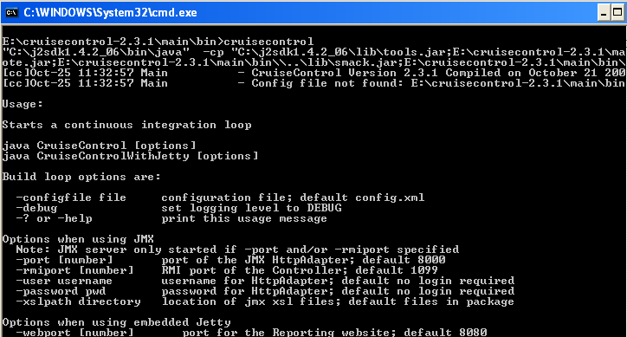
Figure 1 - CC Installed Successfully

2) Setup your Cruise Control working area
Now you need to set up your CC working directories, and config file. These can/should be placed in a separate directory to INSTALL_DIR, as they contain your data, as opposed to CC binaries.
a) Create a working area for cruise, eg /work/cruise. This will be referred to as WORK_DIR.
b) Now create the following subdirectories:
WORK_DIR/logs | This is where cruise will write its build reports into.
WORK_DIR/artifacts | This is where cruise can put any build output files that need to be kept.
Example Directory Structure:
E:/IRI-Builds
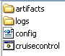
c) Create WORK_DIR/config.xml, like so:
<cruisecontrol>
</cruisecontrol>
d) Now try running CC from within WORK_DIR. (You will need to add cruisecontrol.bat or cruisecontrol.sh to the PATH) by default, CC looks for a config file named "config.xml". Set the Cruise Control PATH (set CCDIR= INSTALL_DIR\main) and ANT_HOME (set ANT_HOME=ANT_INSTALL_DIR) into cruisecontrol.bat file. This should work ok. CC should start up correctly, stating "BuildQueue started". However, to get cruise to actually do anything, you'll need to configure a project.
Cruise Control and Ant Home Path Setup in cruisecontrol.bat file:
########################################################
…………………………….
set DEFAULT_CCDIR=%~dp0
REM : operator works similar to make : operator
set DEFAULT_CCDIR=%DEFAULT_CCDIR%\..
set CCDIR=E:\cruisecontrol-2.3.1\main
set ANT_HOME=E:\apache-ant-1.6.1
if not defined CCDIR set CCDIR=%DEFAULT_CCDIR%
set DEFAULT_CCDIR=
:setClassPath
set CRUISE_PATH=
……………………………………
##########################################################
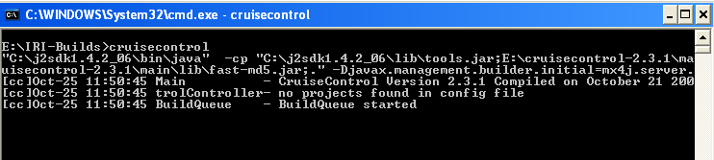
Figure 2 - CC BuildQueue Started
Alternatively, you can run CC from another location, and specify the path to config.xml using the - configfile commandline option. (Be warned: the paths in your config file are relative to the current directory, and not relative to the config file itself.)
NOTE: This directory structure works well for me, but feel free to set things up however you please. The paths to these directories are all specified in the configuration files.

3) Setup a project for Cruise Control to build
a) You now need to write a delegating Ant build script, which cruise will run to build your project. Call this file "build-MY_PROJECT_1.xml" (Example: - build-OMS.xml), and put it in WORK_DIR. Create directory MY_PROJECT_1 (Example: - OMS) under WORK_DIR/logs for putting build status information for your project.
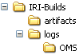
Figure 3 - Project Log Directory
Heres an example of a delegating build script:
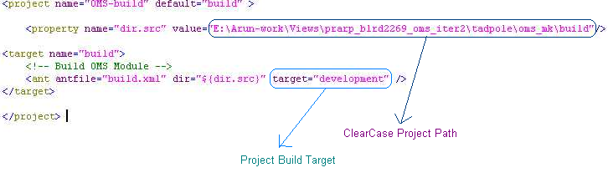
Figure 4 - CC Project Build File

<project name="OMS-build" default="build" >

<property name="dir.src" value="E:\Arun-work\Views\prarp_blrd2269_oms_iter2\tadpole\oms_mk\build"/>

<target name="build">
<!-- Build OMS Module -->
<ant antfile="build.xml" dir="${dir.src}" target="development" />
</target>

</project>

Table 1 - Project Build File (build-OMS.xml)

4) Configure Cruise Control to build your project
You now need to add project information to config.xml, so that cruise will build your project. The config.xml file is the key to your Cruise Control process, so this section is a bit more detailed than some of the others. For more information, see the CruiseControl Configuration Guide.
- Here is a config.xml example for the project configured above. Note that this is the very minimum you'll need; we'll add extra stuff in later. This "project" element is added inside the <cruisecontrol> tags you created earlier:
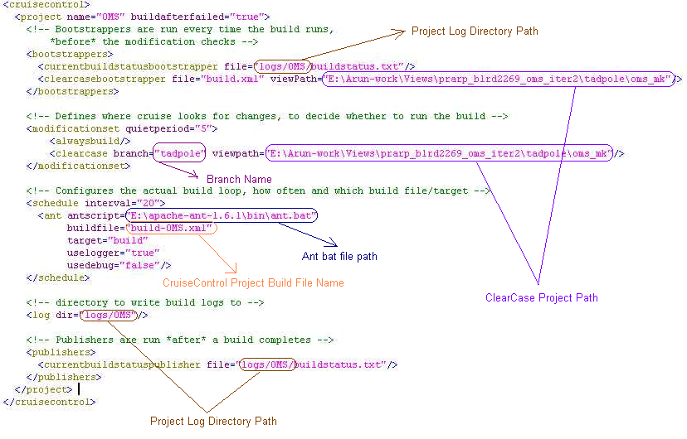
Figure 5 - CC Config File Information

<cruisecontrol>
<project name="OMS" buildafterfailed="true">
<!-- Bootstrappers are run every time the build runs,
*before* the modification checks -->
<bootstrappers>
<currentbuildstatusbootstrapper file="logs/OMS/buildstatus.txt"/>
<clearcasebootstrapper file="build.xml" viewPath="E:\Arun-work\Views\prarp_blrd2269_oms_iter2\tadpole\oms_mk"/>
</bootstrappers>

<!-- Defines where cruise looks for changes, to decide whether to run the build -->
<modificationset quietperiod="5">
<alwaysbuild/>
<clearcase branch="tadpole" viewpath="E:\Arun-work\Views\prarp_blrd2269_oms_iter2\tadpole\oms_mk"/>
</modificationset>

<!-- Configures the actual build loop, how often and which build file/target -->
<schedule interval="20">
<ant antscript="E:\apache-ant-1.6.1\bin\ant.bat"
buildfile="build-OMS.xml"
target="build"
uselogger="true"
usedebug="false"/>
</schedule>

<!-- directory to write build logs to -->
<log dir="logs/OMS"/>

<!-- Publishers are run *after* a build completes -->
<publishers>
<currentbuildstatuspublisher file="logs/OMS/buildstatus.txt"/>
</publishers>
</project>
</cruisecontrol>

Table 2 - CC Config File (config.xml)
- The <log> element tells cruise where to put it's log reports, which are the main output of a Cruise build.
- The <currentbuildstatusbootstrapper> element tells cruise the name of a file where it can write notes about it's current activity. This file is required by the web application, so we configure it here. For multi-project configs it is probably easiest to place it in the project logs directory, as above. This bootstrapper writes "Current Build Started At: date" to this file.
- The <modificationset> element configures how cruise checks for clearcase snap shot or dynamic view changes, before running the build.

6) Start Cruise Control
If you now run cruise from your WORK_DIR, you should see cruise start. To kick off a build, you may need to check in changes to clearcase. If the build fails, cruise will keep on trying, until you get it right. You don't need to restart cruise if you change config.xml or your delegating build file, since cruise reloads these every time a build is performed.
If you look in WORK_DIR/logs/MY_PROJECT_1 (Example: - E:\IRI-Builds\logs\OMS), you'll see the cruise build reports, which are big, ugly XML files. Any file that ends with "build.?.xml" indicates a successful build, while other xml files indicate failures. Fortunately, you don't need to parse these files yourself, because CC provides a web application which can present these results in HTML format. But for now, you're up and running, and every time you check in changes into clearcase, cruise will pick up those changes and build them.
For Starting cruise control:
Go to WORK_DIR, run cruisecontrol.bat file.

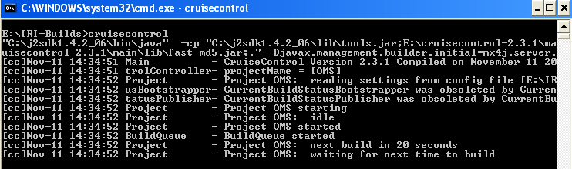
Figure 6 - CC is waiting for Build

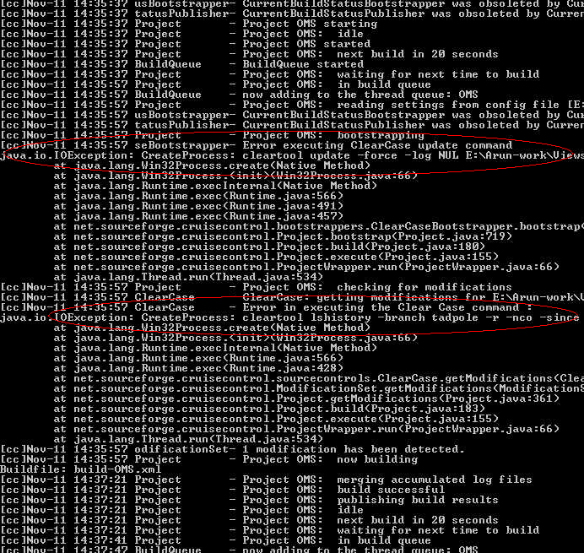
Figure 7 - CC is building OMS Module

Note: We don’t have Clearcase snap shot or Dynamic view, because of that we are getting above clear tool update and lshistory failed Error while running Cruise Control.

7) Building the web app
The CC web reporting application, like CC core, needs to be built before it can be used. This time, the build process needs to be told where to find your WORK_DIR and other details.
Unfortunately, the only way to do this presently is by adding a properties file to your installation directory. Hopefully, we can soon have a webapp build which doesn't require modifications to INSTALL_DIR, but can read these properties from a different file.
a) Open the "INSTALL_DIR/reporting/jsp" directory.
b) Create a new file called "override.properties", the properties in this file will be used to generate the Web.xml (deployment descriptor) for the web app. The file should look like this:
# This should be the full path to your CruiseControl log directory.
# If you are in multi-project mode, there will be multiple sub-directories
# inside this log directory, one for each project.

user.log.dir=WORK_DIR/logs

# This should be the path to your current build status file, # expressed relative to the project's log directory.

user.build.status.file=buildstatus.txt

# This should be the absolute path to the directory where # additional build artifacts are stored.

cruise.build.artifacts.dir=WORK_DIR/artifacts
If using JDK 1.4, add
jdk1.4=true
to override.properties.
c) Generate cruisecontrol.war by executing "build.sh war" or "build.bat war" in the directory INSTALL_DIR/reporting/jsp.
d) Deploy the generated web application "INSTALL_DIR/reporting/jsp/dist/cruisecontrol.war" to your application server, and browse to APPLICATION_PATH/index.jsp. This page provides links to the buildresults page for each project (good for multi-project configurations).
e) The "Build Results" tab provides a formatted set of reports on what was changed, and if the build was successful. The "XML Log File" tag shows the XML log as a raw HTML file. Don't worry about the "Test Details" and "Control Panel" tabs; they are just placeholders, and aren't implemented yet...
NOTE: To run under Tomcat 4.1.27 with JDK1.4, I needed to remove xalan.jar and xerces.jar from the INSTALL_DIR/reporting/jsp/lib directory. These files clash with the regular JDK versions. Do this before step c)

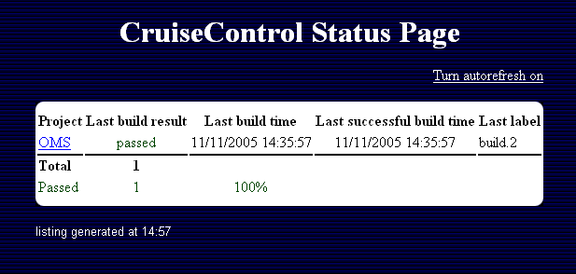
Figure 8 - Cruise Control Status Page

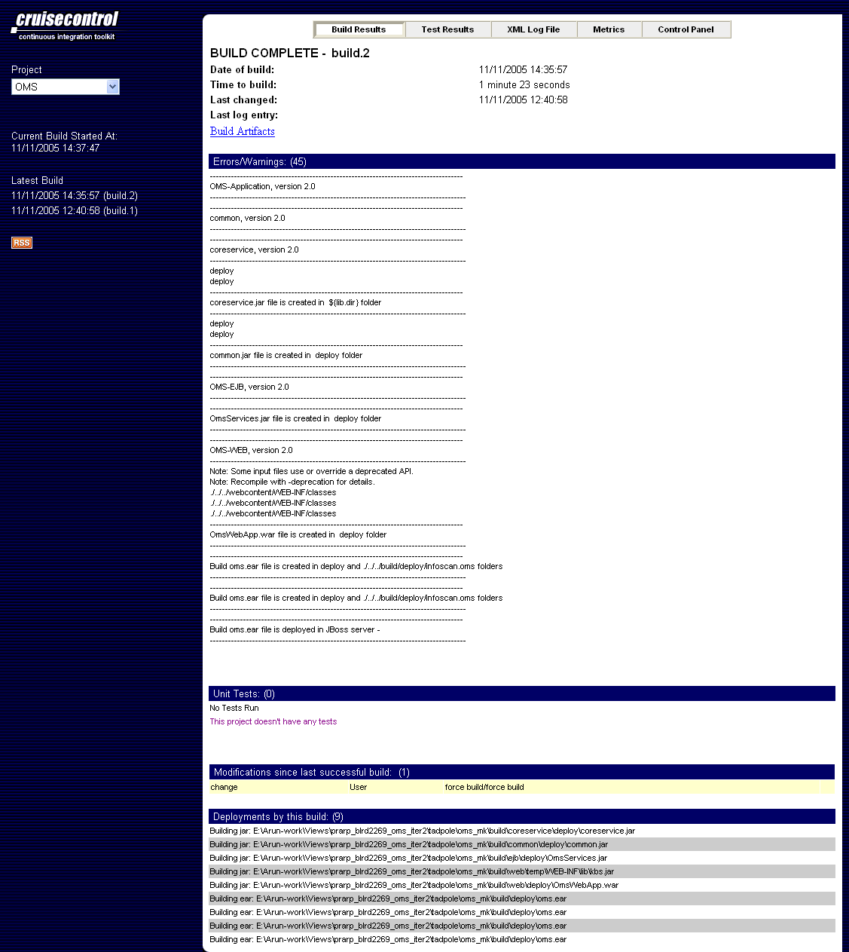
Figure 9 - CC - OMS Build Report Page

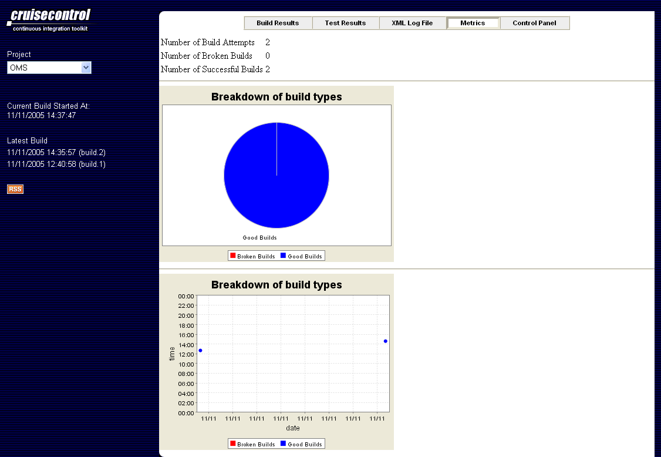
Figure 10 - CC - OMS Build Metrics Page

9) Reporting build status via email
A good way to keep track of your continuous integration is by receiving emails, either for every build, or just for the ones that fail. This is done by adding an <email> publisher to the set of publishers.
a) The most basic email functionality sends emails to one set of addresses on every single build (success or failure), and another set of addresses just on failured builds. To set this up, add an element like this to your <publishers> element:
<email mailhost="SMTP_HOST"
returnaddress="cruise@mydomain.com"
buildresultsurl="http://localhost/cc/buildresults/MY_PROJECT_1"
skipusers="true" spamwhilebroken="true">
<always address="dev1@mydomain.com"/>
<always address="dev2@mydomain.com"/>
<failure address="failed-builds@mydomain.com"/>
</email>
In this case, there are 2 addresses that always get sent build notifications, and another that will only receive notifications of failures.
b) To get nicely formatted HTML mail you need to use the HTML email publisher. Replace <email> with <htmlemail> and add some extra configuration.
Add these 3 required attributes to the <htmlemail> element you set up in step 1):
css="INSTALL_DIR/reporting/jsp/webcontent/css/cruisecontrol.css"
xsldir="INSTALL_DIR/reporting/jsp/webcontent/xsl"
logdir="logs/MY_PROJECT_1"

